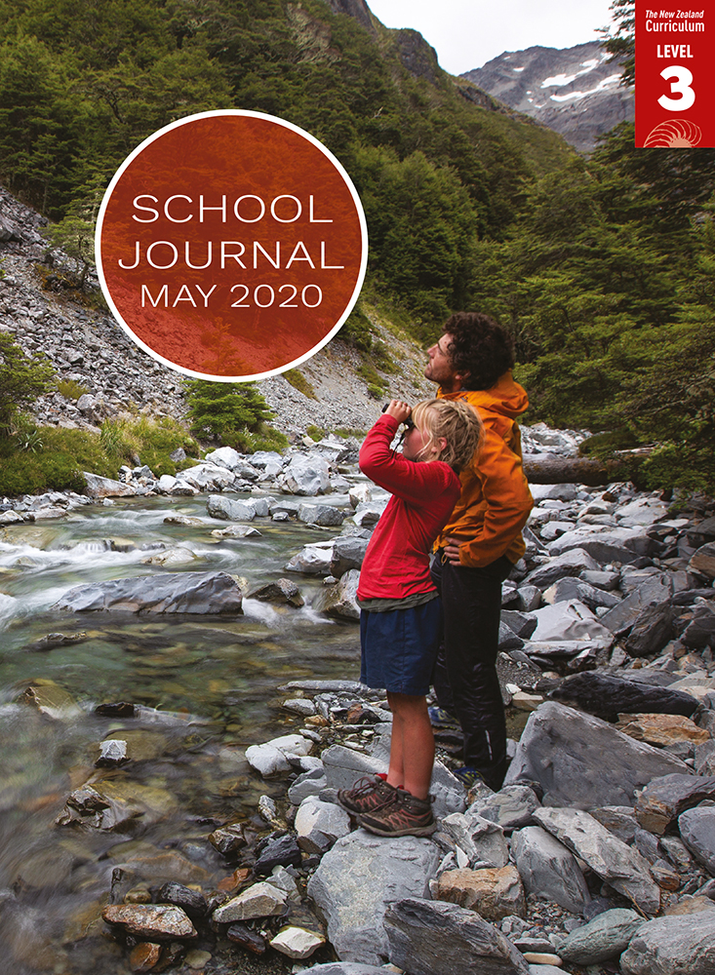

School Journal

Level 3, May 2020

**Year 6**

# Ghost Walk

by Renata Hopkins

[The Learning Progression Frameworks](https://curriculumprogresstools.education.govt.nz/lpf-tool/) describe significant signposts in reading and writing as students develop and apply their literacy knowledge and skills with increasing expertise from school entry to the end of year 10.

## Overview

Grumpa wants to take a walk, but the narrator has other ideas. Grumpa wins, and the pair tour Christchurch’s Red Zone, where the narrator learns to see what’s no longer there – and ways we can preserve the past.

A PDF of the text is available at [www.schooljournal.tki.org.nz](http://www.schooljournal.tki.org.nz)

## Themes

* Change
* Memories and heritage
* The importance of whānau/family

## Related texts

“**Painting the Town**” SJ L3 Nov 2014 | “**In Colour**” SJ L3 Aug 2019 | “**The Penny Walk**” SJ L3 April 2012

## Strengthening reading behaviours (what to notice)

|  |  |
| --- | --- |
| Text structure and features | Requiring students to: |
| * Figurative language and colloquial language * Implied information or ideas, for example, at the end of the story when the narrator is unsettled when Grumpa appears to have vanished * The narrator as an unwilling participant, reluctant to have her screen time disrupted and to do something out of the ordinary | * draw on their prior knowledge of language features and colloquial language to interpret the intended meaning * draw on earlier clues and integrate their inferences across the story to interpret what’s implied * make personal connections to the central character, make inferences, and combine clues to understand her initial reluctance and gradual interest in her grandfather’s story. |

|  |  |
| --- | --- |
| Vocabulary | |
| Possibly unfamiliar words and phrases | observation, numb, grumpier, refreshments, round trip, barrier, pedestrians,  historic landmarks, glided, fortunately, fret |
| Colloquial language and a pun | ready to bolt, Grumpa, you’ve got selective hearing, powers of observation, square eyes, give or take, I knew how to crunch the numbers, Keep your eyes peeled, oldie-vision, munted, the king and queen of the river, isn’t she a beauty? |

|  |
| --- |
| Helpful prior knowledge (pre-reading and introducing the text) |
| * The Christchurch earthquakes had a huge effect on the people living there. |

## Possible reading and writing purposes

* Discover what a grandfather and his granddaughter find on a walk in Christchurch
* Consider how we remember things that have been destroyed or lost
* Understand the importance of preserving memories
* Identify how the author has crafted the characters
* Organise, record, and communicate ideas and information from the text

See *Effective Literacy Practice in Years 5–8* for information about teaching comprehension strategies ([Teaching comprehension](http://literacyonline.tki.org.nz/Literacy-Online/Planning-for-my-students-needs/Effective-Literacy-Practice-Years-5-8/Teaching-comprehension)) and for suggestions on using this text with your students ([Approaches to teaching reading](http://literacyonline.tki.org.nz/Literacy-Online/Planning-for-my-students-needs/Effective-Literacy-Practice-Years-5-8/Approaches-to-teaching-reading)).

## Possible curriculum contexts

This text has links to level 3 of the New Zealand Curriculum in: [**ENGLISH**](http://nzcurriculum.tki.org.nz/The-New-Zealand-Curriculum/English) [**HEALTH AND PHYSICAL EDUCATION**](http://nzcurriculum.tki.org.nz/The-New-Zealand-Curriculum/Health-and-physical-education)

## Understanding progress

The following aspects of progress are taken from the [Learning Progression Frameworks](https://curriculumprogresstools.education.govt.nz/lpf-tool/) and relate to the specific learning tasks below. See the LPFs for more about how students develop expertise and make progress in these aspects:

* Reading for literary experience
* Making sense of text: reading critically
* Reading to organise ideas and information for learning
* Using writing to think and organise for learning.

## Strengthening understanding through reading and writing

The *School Journal* provides rich texts that can be returned to many times. The following suggestions are based on the premise that rereading the text is a fundamental part of developing students’ understanding and reading skills. **Select from and adapt** them, according to your students’ strengths, needs, and experiences.   
Note: Most of these activities lend themselves to students working in pairs or small groups.

* Use a T-chart to organise what the students found out about Christchurch. Include evidence from the story.
* List clues to the past found in the story. The students could create their own way to present these clues, such as colour coding or arranging the clues according to what is directly told, seen in visual images, or inferred.
* Raise questions to form the basis of further investigation. As a group you might write “I wonder …” in the centre and record their questions as they read for a second time. Pause to model questions, such as “How many houses are in the red zone?”, “How long did it take to remove the houses and buildings?”, “Where have the people who lived there gone?”. Have the students work in pairs to find information about one of the questions and include maps and any found images in their responses.
* Ask the students to write a recount of a particular walk or journey they have been on with an older relative.
* Have the students describe a special memory or an aspect of the past they have heard about from someone in their whānau.
* Have the students profile one of the main characters. They could use the **Character map** template provided.
* Explore interesting vocabulary or descriptive phrases. The students could add stickies to anything they particularly liked, then as a group, draw out the literary features, such as colloquial language, metaphors, or puns. Discuss how these help them to visualise the story. To support English language learners with colloquial language and the idioms, you could have them draw or act out the phrase while the other students try to guess what it is. Alternatively, they could design posters drawing the literal meaning on one half of the page and the actual meaning on the other.
* In pairs, have the students take turns to orally describe a place that is special to them. Their partner could draw the special place, and then discuss how easy it was for them to form a picture from the description.
* Have the students draw a map and label a place of personal significance.
* Walk the rooms of an invisible special place. In pairs, the students show their partner around, pointing out special features. Some English language learners may need support to use prepositions when describing their place, for example, above, under, next to.
* For more ideas and strategies to support English language learners, see [ESOL Online](https://esolonline.tki.org.nz/).

“Ghost Walk” Character map

|  |  |
| --- | --- |
| **Character** | |
| **Appearance** | **Personality** |
| **Likes/dislikes/feelings** | **Character traits/behaviours** |
| **How the character changed** | |